**Program Title:** Write a program which contains a class named Box and the member of the class are a construct without parameter , a constructor with para meter, a destructor, 3 data member named height, width and area, 3 member function named set_height,set_ width and get_area, all member function's return type is void except get_area.Now find area of object named box.

**Source code:**

#include<iostream>

using namespace std;

class Box {

float height,width,area;

public:

void set_height();

void set_width();

double get_area();

Box() {

height=0.0;

width=0.0; }

Box(float x,float y) {

height=x;

width=y; }

~Box()

{

}

};

int main() {

double area;

Box b1,b2(5.0,10.0);

b1.set_height();

b1.set_width();

area=b1.get_area();

cout << "The area of first one:" << area <<endl;

// b2.set_height();

//b2.set_width();

area=b2.get_area();

cout << "The area of second one:" << area <<endl;; }

void Box :: set_height() {

cout << "Enter height:" <<endl;

cin >> height; }

void Box :: set_width() {

cout << "Enter width:" <<endl;

cin >> width; }

double Box :: get_area() {

area=height*width;

return area;

}

**Output:**

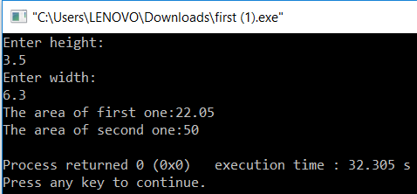



[Date]

**Submitted To:**

Name: M.M. Fazle Rabbi

Assistant Professor, Dept. of CSE

at Bangladesh University of Business and Technology.

**Submitted By:**

Name: Syeda Nowshin Ibnat

ID :17183103020

Intake :39

Section: 1

Program:B.SC. in CSE

Assignment On

Class and Object

**Course Title:** Object Oriented Programming Language

**Course Code:** CSE 121

**Date of Submission:19.02.19**